Week4

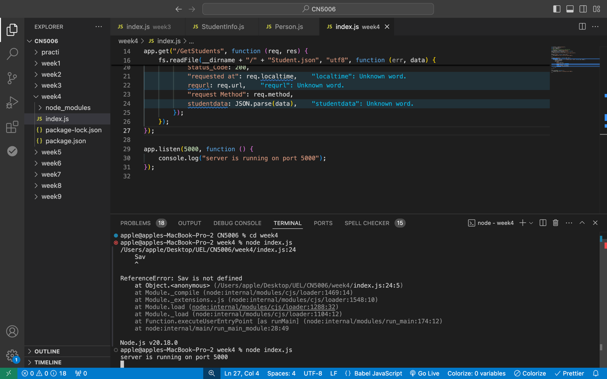

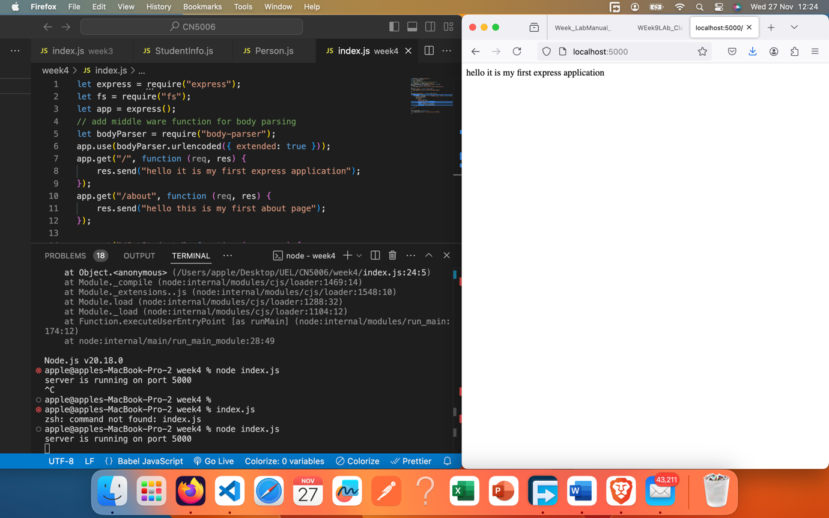

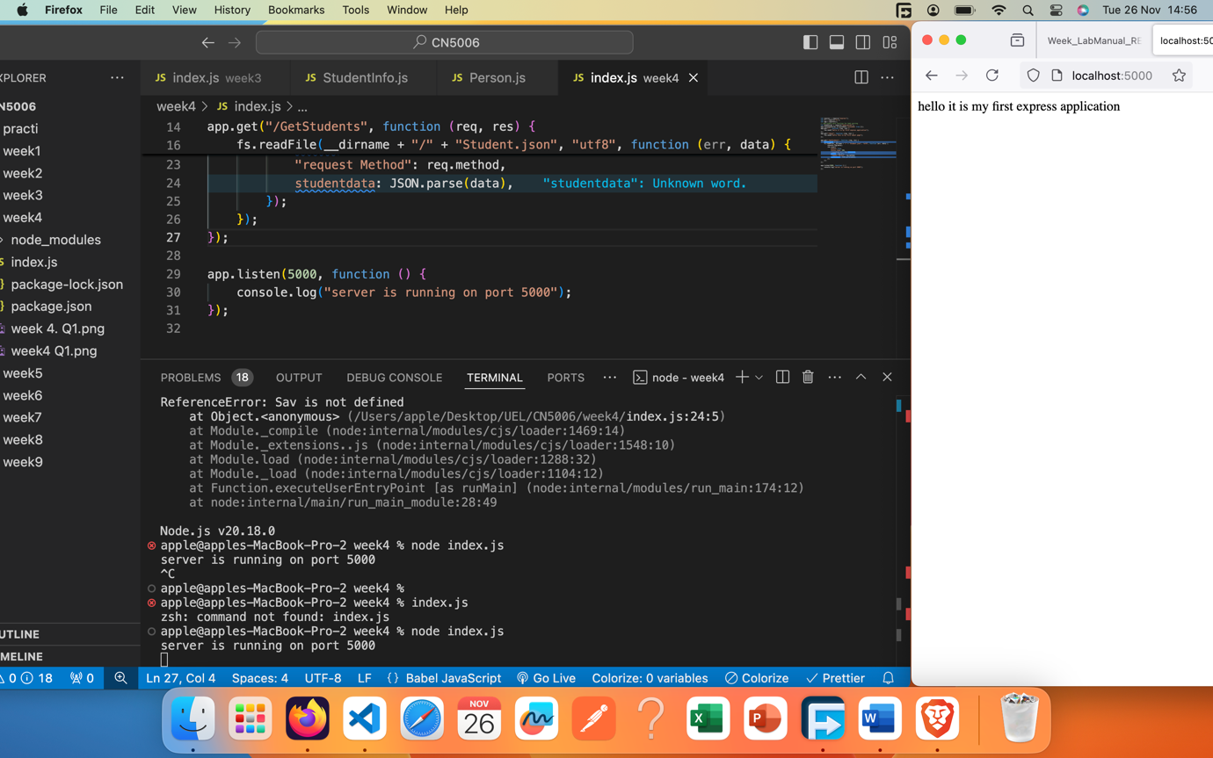

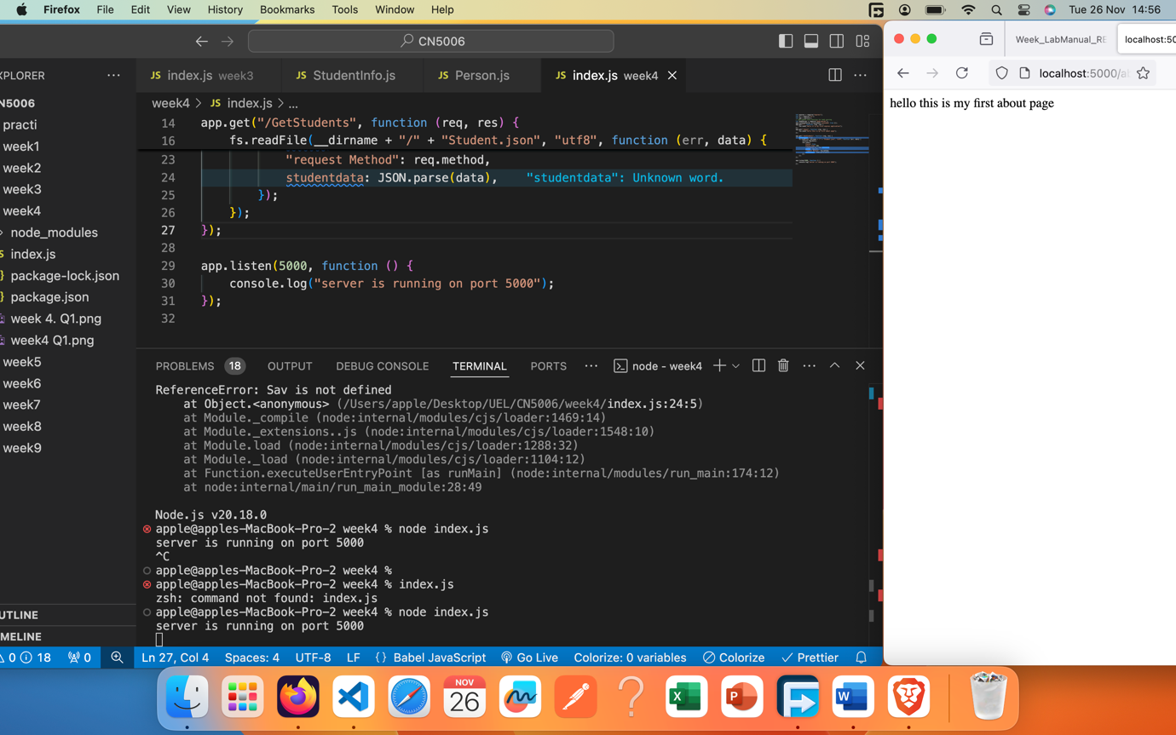

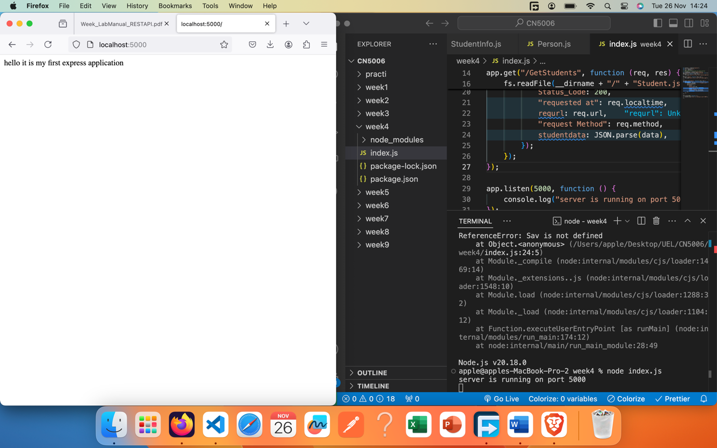

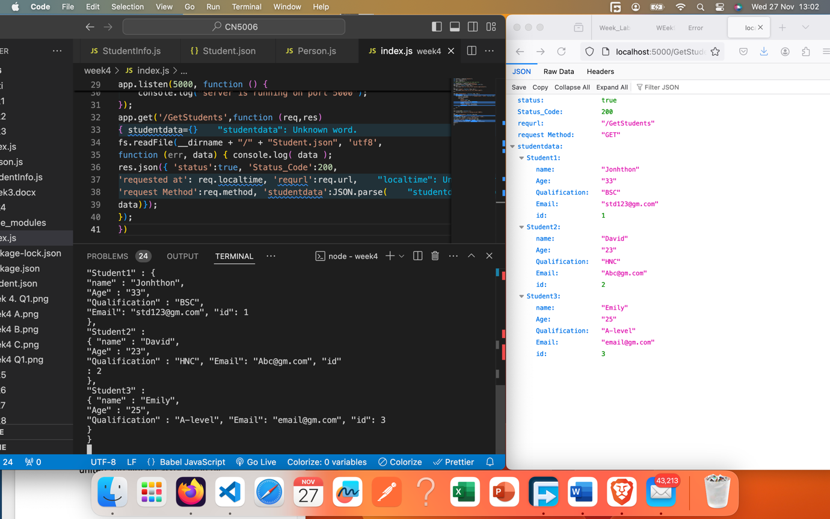

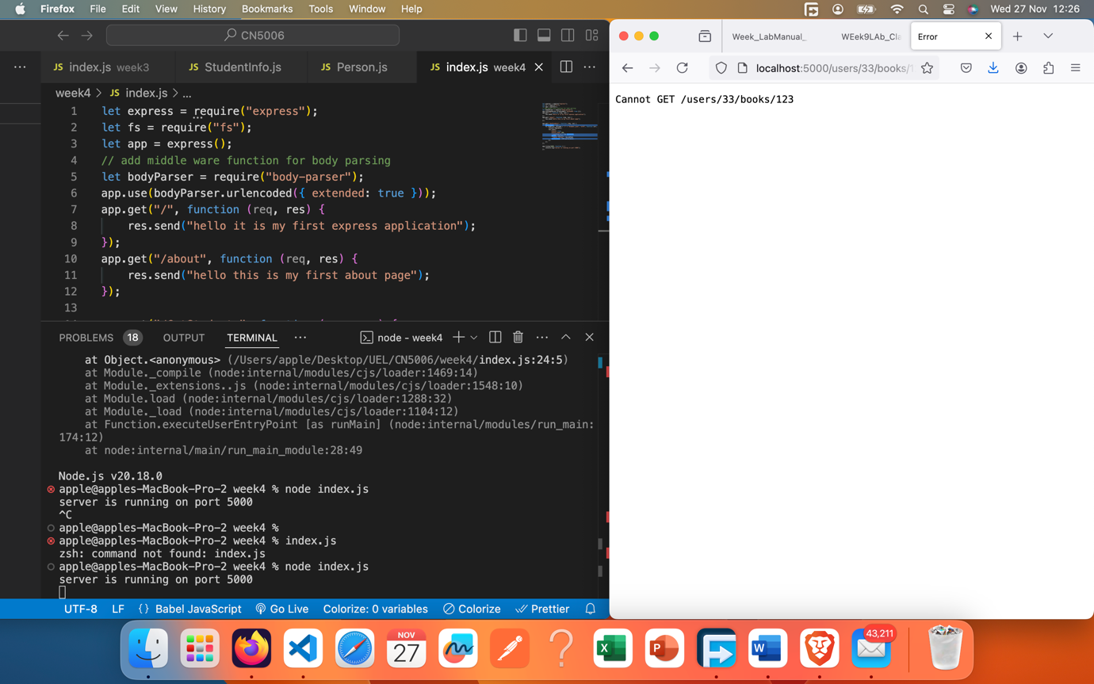

{

"Student1" : {

"name" : "Jonhthon",

"Age" : "33",

"Qualification" : "BSC",

"Email": "std123@gm.com", "id": 1

},

"Student2" :

{ "name" : "David",

"Age" : "23",

"Qualification" : "HNC", "Email": "Abc@gm.com", "id"

: 2

},

"Student3" :

{ "name" : "Emily",

"Age" : "25",

"Qualification" : "A-level", "Email": "email@gm.com", "id": 3

}

}

Student data is coming from Jason file.

Run from res.jason